Home work of Dubova Serafima for the course BK70A0600

Student number 000333434 (x101769)

Firstly, we solve equation below and achieve such graphs (pic. 1)

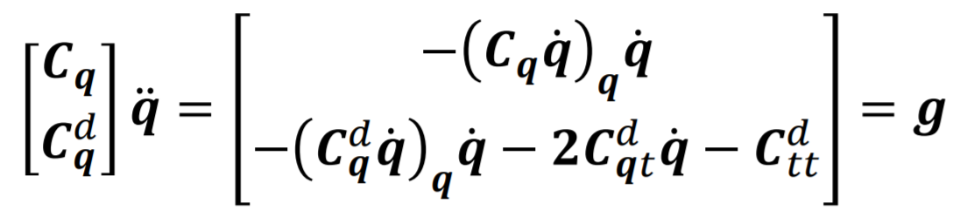

In this equation

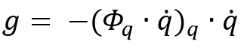

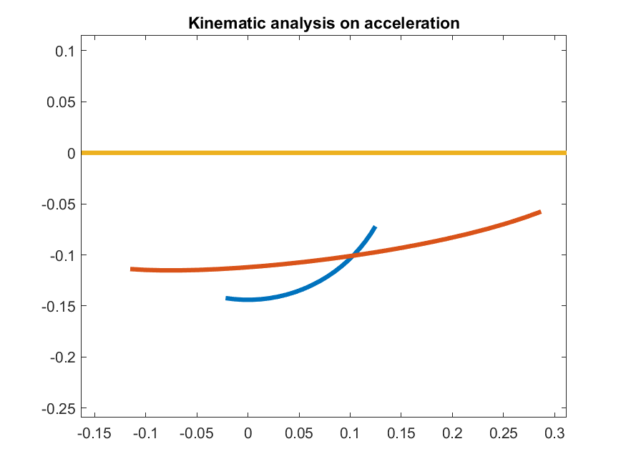

Picture 1 – Kinematic analysis on acceleration

Equation of transitional joint:

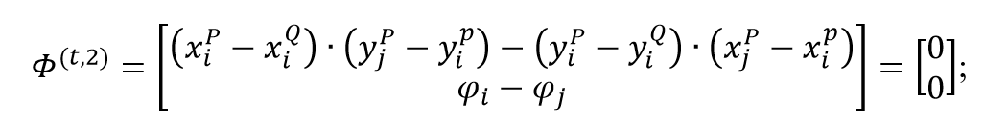

when solving this equation, we get the same graph as in the previous time (pic 1.)